**Website Usability Report for**

**Gym and Nutrition (Dot-com)**

<http://gymandnutrition.com>



Prepared for:

National College of Ireland

Mayor Street, Dublin 1, Ireland

Module: Usability Design

Prepared by:

Navjot S. Virk

[Virksaabnavjot@gmail.com](mailto:Virksaabnavjot@gmail.com)

March, 2017



Table of Contents

1 Abbreviations and Acronyms Used 3

2 Overview and the purpose of the Report 3

Goals and Objective of Gym and Nutrition Dot-Com 3

Figure 1: Current Version of GN Website 4

Site Overview 4

Site Logo (Small) 4

Site Logo (Main Logo) 4

How Gymandnutrition.com achieve its goals? 4

Figure 2: Screenshot of the community forum where people find useful content 5

Figure 3: Website provides easy Login/Register on each page. 5

Figure 4: Easy Registration Form 5

Figure 5: Websites income source (Advertisement) 6

Introduction to Usability 6

Site Stakeholders and Users 7

Stakeholders 7

Users 7

3 Competitive websites 7

1 - Bodybuilding.com (BB) 7

Figure 6: Website of Competitor (Bodybuilding.com) 8

Applying Effective Usability Criteria (Bodybuilding.com) 9

2- Muscle & Fitness (M&F) 9

Figure 7: Website of Competitor (Muscleandfitness.com) 10

Applying Effective Usability Criteria (Muscleandfitness.com) 11

4 Primary needs and requirements 11

Site Owner’s Organisation and users under study: Scenario 11

To Register new users to the site 11

To Register new moderators and content writers 12

To promote community involvement through quality content and free fitness programmes 12

To Rank higher on Search Engines 12

Earn revenue through advertisement 12

Site users: Scenario 12

Prospective users 12

Moderators and Content Writers 13

Contributors (Donors) 13

Content Fans 13

Use Case 1 (Prospective Fitness Freshman) 13

Use Case 2 (Prospective Advanced Fitness Enthusiast) 13

Use Case 3 (Prospective Content Writer) 13

5 Site design & navigation 13

Information Architecture 13

Figure 8: Example of good Information architecture 13

Figure 9: A good example of vertical menu 14

Figure 10: Good example of horizontal menu 14

Figure 11: And in more complicated sites, their may be a need of mixture of the two 15

Organisation Scheme for Gymandnutrition.com 15

Scheme 1: Role Based Organisation 15

Scheme 2: Structure Based Organisation 16

Scheme 3: The Hybrid Scheme - combining both the structures 16

Recommended Navigation Scheme for GN Website 16

Writing Quality, Appropriateness and Value of Site Content 17

Current GN Website 17

6 Heuristic Evaluation 18

Recognised Usability Heuristics 18

Heuristic Evaluation Results Summary 18

7 Conclusion & Recommendations 19

Conclusions 19

Recommendations 20

8 References 20

9 Appendix 21

# Abbreviations and Acronyms Used

|  |  |
| --- | --- |
| Gymandnutrition.com | GN, GN Website, Gym and Nutrition |
| Bodybuilding.com | BB, BB Website |
| Muscleandfitness.com | M&F, M&F Website, Muscle and Fitness |

# Overview and the purpose of the Report

The purpose of the report is to provide a complete analysis of the GN (Gym and Nutrition) website (<http://www.gymandnutrition.com)> of the current version of the website. In order to learn weather users could gain understanding of the website structure and be able to perform common tasks with ease. Through, the course of the report, several analytical methods were utilised to determine whether the current version of the website successfully fulfils the business goals and objectives of the Gym and Nutrition.

## Goals and Objective of Gym and Nutrition Dot-Com

Attracting and keeping engaged thousands of fitness enthusiasts, and provide a powerful community for people to ask questions and be able to contribute to fitness community.

|  |  |
| --- | --- |
| Figure 1: Current Version of GN Website |  |

## Site Overview

Logo plays a large role in building brand name and brand recognition and for any business in the world that is very important and GN Website is no exception.

Site Logo (Small)

|  |  |
| --- | --- |
|  | GN representing Gym and Nutrition along with Apple and milk representing fitness (Meaningful logo). |

Site Logo (Main Logo)

|  |  |
| --- | --- |
|  | Simple but meaning full logo with a Bodybuilder symbolising - “gym” and Apple & Milk symbolising – “nutrition”. |

Let’s take an extensive look at the higher level view of the whole GN Website. And its layout and how it works (it’s usability). When, a user visits GN Website they are most probably looking for useful content either on gym or nutrition or both.

GN (Gym and Nutrition) is a community forum, along with blog to help people stay fit and live a better life.

## How Gymandnutrition.com achieve its goals?

GN website is fairly newly established website and new content is being posted on daily basis, the content available on website currently focuses on fat loss and nutrition based content of whole foods. The aim of GN, is to provide an easy to use and interact with platform to people looking for ways to improve their health. To achieve its aim GN provides an easy to use forum software on their website, using which new users can easily register with the site within 15 seconds and start asking their health, gym and nutrition related questions and also contribute towards the community through answering other people’s questions.

|  |  |
| --- | --- |
| Figure 2: Screenshot of the community forum where people find useful content |  |
| Figure 3: Website provides easy Login/Register on each page. |  |
| Figure 4: Easy Registration Form GN team also seems to be dedicated to providing quality answer to their users and also provide useful blog with quality fitness related content. GN, currently does not sell any products or services on their websites but may do so in future as we know every one of us want to be fit and fitness industry attract a lot of people and there is a high demand of fitness related content/services (digital) and products. Currently, the source of income for the website is through AdSense advertisement and some affiliate marketing. |  |
| Figure 5: Websites income source (Advertisement) |  |

## Introduction to Usability

For an organisation to reach its audience, website is an important gateway. Website helps organisation to deliver/showcase its information, products and services to its users. As such, website should exactly reflect user needs/requirements it’s designed for?

The irony is the website development and design is often focused on making the website look good and neglect the usability aspect, and designers designing the website according to their thinking and view of the problem, technology and business objectives) instead of focusing on user needs.

In recent, times people have started focusing on usability when under pressure from competitors in race to be the best or by paying attention to customer complaints and improving the solution.

Defining the usability of the website may be confusing to many people and discussions are ongoing. To a degree usability depends on the target user and purpose of the website.

In general, a usable website is the one that is easy to learn, navigable, consistent, provide accessibility and availability, clarity, relevancy, guidance, credibility and learnability and allow quick recovery from errors that is provide an opportunity for the customer to redo/undo.

These days the internet is huge and we are able to find just anything, which interns means lots of options for users and Web users are very picky and desire great experience – if they don’t like the design or not able to find something for a second they get frustrated and quickly exit the site and are not likely to return. For business and content sites if the website is very hard to use and find the services and content it may cost the business the clients or potential content subscribers. Hence, loss of revenue.

Challenges related to Usability design for people trying to incorporate usability into their websites –

* Increased user expectations due to huge size internet is difficult to satisfy.
* When assessing a site, a user hasn’t invested like in a software package and other options are available
* Widely different user experience to users due to different hardware, network and software platforms available of the same website.
* There is always something to be improved.
* New development in technology, in short time washes away the efforts made previous technology and force business to invest in new technology to stay competitive.

## Site Stakeholders and Users

The following list represent the stakeholders and users of the GN website –

|  |  |
| --- | --- |
| Stakeholders | Users |
| * Owner of the Website * Content Writers * Moderators | * Prospective Users * Loyal Users (Fitness Enthusiasts) * Contributors (Community) |

# Competitive websites

Fitness industry is huge and we all dream about the perfect body. Hence, fitness industry is very attractive and lucrative market. Gymandnutrition.com focuses on gym and nutrition content and has large number of competitors competing for the same audience.

Below are 3 credible competitors’ to GN website –

## 1 - Bodybuilding.com (BB)



Website: <https://bodybuilding.com>

Logo: (Very simple and stylish, Sky blue background and white coloured letter “B” - short for body building).

|  |  |
| --- | --- |
| Figure 6: Website of Competitor (Bodybuilding.com) |  |
| Figure 6.1: Bodybuilding.com - Content Layout Latest article stays at the top of the page, with a catch heading and a good design principle used – an image, heading and a short description which makes easy for user to understand what’s in the post before opening it. BB features their recommended articles on the left sidebar and it brings ease for users to navigate the site and find useful content. |  |
| Figure 6.2: Bodybuilding.com - Menu when hovered over The menu’s single tab contains a lot of options on mouse over, which may intimidate some users and users may find it hard to learn to navigate the site and certainly more time consuming. |  |

**Bodybuilding.com (BB)** is a big player in fitness industry their website has a clean design with a good menu design which expands on hovering over and provides all useful links under a topic (but too many options).

**Strengths:**

BB also provide quality content on gym and nutrition and is a direct competitor to Gymandnutrition.com, GN website can compete BB by providing unique and focused, collaborated and right content users are looking for constantly people are looking for alternatives and here is where newly launched GN website can improvise and build large user base.

Overall, BB website website is: clear, credible, accessible, provide relevant content and services.

**Weaknesses:**

BB Website has a flashy little ad on the top of its homepage which can be annoying to some users and in general pages on BB website includes a lot of images & video content and takes b/w 4 sec - 20 sec or more to completely load the page. GN Website can utilize these weaknesses of BB and attract users that expect speed and less flashy advertisements.

### Applying Effective Usability Criteria (Bodybuilding.com)

5 criteria that a product must meet to be usable:

|  |  |
| --- | --- |
| 1.**Effectiveness:** | (High) include fixing credit card filled, email address. |
| 2.**Efficiency:** | (Medium) The site lacks speed at times due to high volume of photos and videos served. Too much options and information and user may get lost in this pool of info. |
| 3.**Engaging:** | (High) Proper layouts, readable typography |
| 4.**Error Tolerance:** | Medium |
| 5.**Easy to Learn:** | No |

**Others**

**Consistent:** Fairly consistent design and colour schemes around the site

**Accessibility and Availability:** High

**Relevancy:** High (provide relevant content).

**Guidance:** Provides no guidance tips on how to use the site on first visit.

**Credibility:** Very high (domain registered since 16-2-1999) Source: Whois

## 2- Muscle & Fitness (M&F)

Website: <http://www.muscleandfitness.com>

Logo (Very basic, plain words no design and lacks creativity in comparison to GN and BB logo’s, simplistic but also appeling to some people due to simplicity and clarity).

|  |  |
| --- | --- |
| Figure 7: Website of Competitor (Muscleandfitness.com) |  |
| Figure 7.1: Muscleandfitness.com - Content Layout Few featured posts on hot topics, to grab user attention, then a list of posts easy to use. |  |
| Figure 7.2: Muscleandfitness.com - Menu when hovered over Simple, clear and straight forward less clutter in the menu, which can be considered as good sign as the user will find it easy to navigate through site and feel less intimidated without too much options. |  |

**Muscle & Fitness (M&F)** is also a big and old player in fitness industry like BB, provides simple to use website and the site looks like site has been designed in early 2000’s but the layout and design is up to the good usability standards.

**Strengths:** Website is simple and established and does well on SEO

**Weaknesses:** Quality of content in comparison to Bodybuilding.com. This is where GN website can compete with M&F by providing good content.

### Applying Effective Usability Criteria (Muscleandfitness.com)

5 criteria that a product must meet to be usable:

|  |  |
| --- | --- |
| 1.**Effectiveness:** | (High) include fixing credit card filled, email address. |
| 2.**Efficiency:** | (High) Less options to choose from easy to navigate around site.    Source: <https://tools.pingdom.com/#!/dKp4WH/http://www.muscleandfitness.com/> |
| 3.**Engaging:** | (High) Proper layouts, readable typography. |
| 4.**Error Tolerance:** | High |
| 5.E**asy to Learn:** | Yes, simple design and simple options to choose from. |

**Others**

**Consistent:** Fairly, consistent design all around the site.

**Accessibility and Availability:** High

**Relevancy:** High

**Guidance:** Provides no guidance tips on how to use the site on first visit.

**Credibility:** Very high (domain registered since 17-07-1997) Source: Whois

# Primary needs and requirements

## Site Owner’s Organisation and users under study: Scenario

**Site Owner's Primary Business Needs and Objectives**

* To register new users to the site
* To register new moderators and content writers
* To promote community involvement
* To rank higher on Search engines
* Earn revenue through advertisement

### To Register new users to the site

Most website’s these days provide user registration and there is a lot of competition and users are picking about signing up on sites. GN is no exception and GN will also need to be focused on narrowing down the user registration process and make it more easy and efficient for users and provide value to them. Example: user gets additional features/access upon registration compared to unregistered users.

### To Register new moderators and content writers

Content sites must have moderators and good content writers. GN is attempting to attract loyal users that can be promoted to moderators to maintain quality over site and since GN provides blog content along with forum community it needs quality content writers (mainly nutritionists, trainers and body builders). People who can bring their expertise, knowledge and experience, which can help boost GN website income through advertisement, adding credibility and higher standing on search engines and increase in user subscriptions to forum and more user contribution, engagement and interest.

### To promote community involvement through quality content and free fitness programmes

The key to success for any content website is having good reputation in the community. As, such GN will need to contribute high quality content for the fitness community and provide people with some free fitness plans. GN has a forum platform and Facebook business page to promote and share its content and it can utilize it to reach more people in the community and improve fitness community and bring awareness among people.

### To Rank higher on Search Engines

Being on the top page of search engines is the goal for every site these days as we know who clicks other results other then first 2 results, very few people. So, GN needs to focus to improve its Search Engine Optimisation (SEO) in order to rank higher and receive more page views.

### Earn revenue through advertisement

Currently, GN does not sell any products/services on its site and its only income source is advertisements and hence needs quality content and strong SEO in order to get thousands of page views and good amount of ad clicks in order to earn profits. For, this GN will require around 200 quality articles, each article attracting on average 1000 page views daily.

**Specific Website Objectives**

* Assist the users to register and find the articles they are looking for through easy navigation structure
* Create a forum community
* Involvement of fitness gurus to boost website credibility

## Site users: Scenario

**Targeted users need and objectives –**

### Prospective users

Prospective users need to have the gym and nutrition information available to make a decision to register with the site. Websites these days are frequently crawled by users and the best (in terms of support, size and volume of content available) is chosen when considering to join an online community. The prospective students need to be able to finds informative articles related to gym and nutrition, meal plans and the registration process.

Be able to check website credibility through the number of Facebook page followers and the people associated with the site.

### Moderators and Content Writers

Moderators and content writers are mostly interested in opportunities like rewards for the Best content writer and Moderator of the month, which provides them with small financial gains and increase in reputation in the community.

### Contributors (Donors)

The fitness geeks that contribute to the site and community for no financial gains but as a hobby and want to help other people, they must be able to easily register and contribute right away and gain recognition in the forum community.

### Content Fans

The sites subscribers/fan must be able to receive all the latest news and articles and be able to also share content on social media sites with ease.

**Use Cases –**

### Use Case 1 (Prospective Fitness Freshman)

John, a 19 years old college student attending college wants to get started with fitness and build a healthy physic. John has never gone to gym or followed a strict healthy diet before. This individual will need to know how to get started with gym and what nutrition is needed like John wants to loose fat, he needs articles and information regarding fat loss and must be able to ask his question to the community on the site.

### Use Case 2 (Prospective Advanced Fitness Enthusiast)

Navjot, is 22 years old, and has been to gym and used to running and cycling before he has landed up on the GN website, he will need to see high quality advanced content on the site to get his attention as he already knows the basics and here the GN website credibility and help needs to be strong in order to hold on to this kind of users.

### Use Case 3 (Prospective Content Writer)

Josh Protein, is a 35 years old fitness enthusiast and love writing content on fitness and nutrition topics. He is looking for opportunity at GN and work from home. Josh found a nutrition content writers job description in the careers section of the GN website and would like to apply. Benefits like flexible hours is must as Josh needs to take care of his family.

# Site design & navigation

## Information Architecture

Lets, first understand Information Architecture (IA) for websites –

IA is the practice of deciding on how to arrange parts of the website to make it more understandable and is used to gain competitive advantage.

### Figure 8: Example of good Information architecture

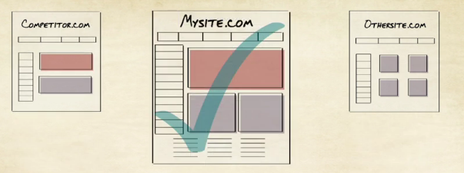Here, the mysite.com example presents its information in a very neat and clean way using all the available space on the page where as other sites lack this.

As, we know there are millions of websites, and different websites require different navigation scheme. Some websites may be able to achieve its goals with some less deep menus (example: gymandnutrition.com) and other sites may require deep menus with more complicated menu structure (this happens when, there is a lot of information to be displayed (example: bodybuilding.com).

The other thing to consider is, the number of top level menu items. If there are a lot of menu items at top level a vertical menu would suit the best, and if few top level menu items the horizontal menu will be best suited.

|  |  |
| --- | --- |
| Figure 9: A good example of vertical menu  Google Play store - <https://play.google.com>, nice and clean. |  |
| Figure 10: Good example of horizontal menu Apple Inc. Website – <https://apple.com>, it has a clean menu with 7 menu items which probably what would fit in that space |  |

|  |  |
| --- | --- |
| Figure 11: And in more complicated sites, their may be a need of mixture of the two Inovies  Website: <https://www.inovies.com/> is a good example of site with mixed menu. It has a horizontal menu at the top with few items and a vertical menu with a lot of menu items as well.  I think the delineation b/w the two is the top menu is more content related while the vertical menu is more business/services offerings. |  |

These days, many sites have a complex navigational structure which requires more than 1 navigational scheme on a page. This makes the designs a lot more complicated, as they need to be organised in a way that its easy for the user.

## Organisation Scheme for Gymandnutrition.com

Organisation Scheme – deals with how the information on the website is categorised and the different ways you can create relationships between each pieces. We use organisation schemes everyday without realising it. Internet Websites, Supermarkets, Telephone books, Library etc.

For a website like Gymandnutrition.com, where different people with different needs are served, a good complex information architecture will be required.

Since, GN website serves to many user roles like beginner’s, intermediate, advanced and guru in different categories like gym, nutrition, fitness, fat loss etc. Having, a hybrid scheme (role and structure organisation) would suit the best for GN website which will allow it to serve every role in each category.

For the purpose of this report, I will outline 2 information architectures – Role based architecture and Structure/Category based architecture.

### Scheme 1: Role Based Organisation

In this organisation structure, the site architecture and key navigational elements is based on the role of the user visiting the website. For, Gym and Nutrition the most logical sequence could be –

* Prospective Content Writers
* Nutrition Experts
* Gym Experts
* GN Athletes (GN in future, may hire some athletes)

### Scheme 2: Structure Based Organisation

In this structure, the site is organised based on the topics the users may be interested in. For GN, this will be:

* Gym and Workouts
* Nutrition
* Health (Everyday Well being)
* Ask Questions? (Forum) using a topic tag.

This structure can be further broken down into subgroup using sub menus –

For example:

**Health**

* Hair Health
* Eye Health
* Liver Health
* Skin Health
* Kidney Health, etc.

### Scheme 3: The Hybrid Scheme - combining both the structures

Since, GN website is focused on serving millions of people with quality information to organise its information it will require a hybrid of role and structure based organisation, whereas at present the GN, website only uses Structure based.

### Recommended Navigation Scheme for GN Website

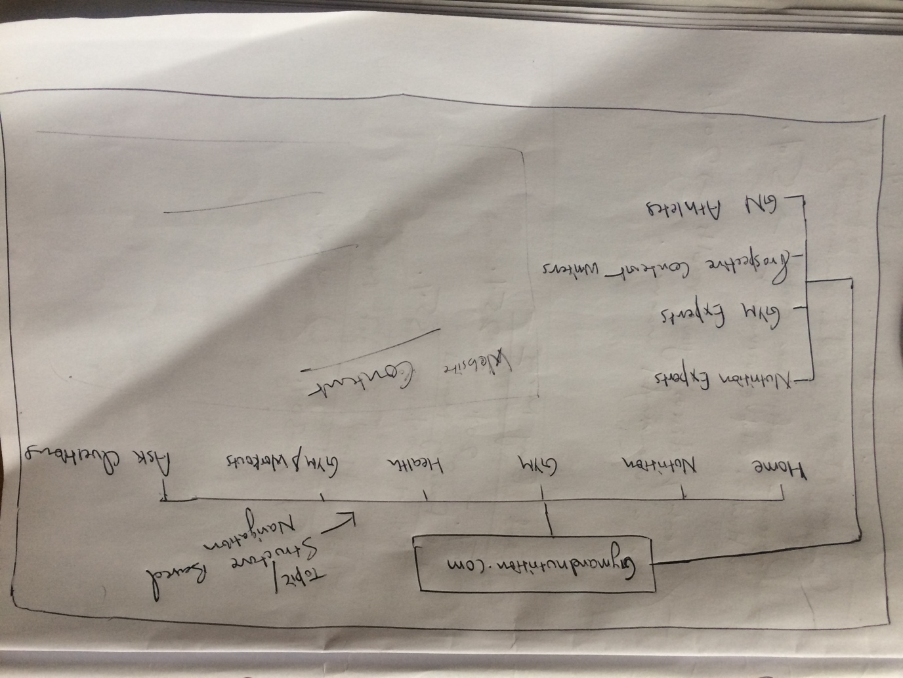

## Writing Quality, Appropriateness and Value of Site Content

The content on Gym and Nutrition, is limited at this stage known the fact its established recently, whereas the content available on the website provided by GN experts is high quality on various relevant topics and professional language is used, the article content comes from text and unique meaningful images and adds value to the internet and fitness community and the content posted on the forum by the users may vary in quality and will require moderation at scale as the platform becomes more mature and popular.

### Current GN Website

The analysis would be incomplete if, the current navigational structure of the GN website is not presented. In the current site the navigation is placed on the top and other navigations are as follows –

|  |  |
| --- | --- |
| Top Level Menu | Other Navigations Menus/Topic based navigation |
|  |  |

After main menu, rest of the navigation, on the current GN website is based on forum topics, recent topics, most voted, top rated topics and articles.

# Heuristic Evaluation

As we know, Heuristic Evaluation helps find usability problems by comparing with recognised usability principles. This Heuristic evaluation involves study of UI of Website by a group of 10 people who inspect the website for violation of usability principles.

## Recognised Usability Heuristics

* Visibility of System Status
* Match b/w System and Real World
* User Control and Freedom
* Consistency and Standards
* Error Prevention
* Recognition rather than recall
* Flexibility and Efficiency of Use
* Aesthetic and Minimalistic design
* Helps users recognise, diagnose, and recover form errors
* Help and documentation

## Heuristic Evaluation Results Summary

For a listing of questions asked by the users of heuristic evaluation refer to appendix.

* Visibility of System Status – GN provides all the recent topics, most rated topic on all its pages along with home tab on each page to get back to home page.
* Match b/w System and Real World – In general, GN website uses simple language and website does not contain any set of terms that users may have problems understanding, whereas it does contain some fitness related abbreviations that may not be know to few people. But the website addresses the problem, by providing a internal link to those abbreviations, upon clicking another website page opens with the description and explanation of the abbreviations. Example- [BMR](http://gymandnutrition.com/forums/topic/basal-metabolic-rate-bmr/) (Basal Metabolic Rate)
* User Control and Freedom – User is able to easily navigate back and forth to the starting point. And find the relevant topics with ease. Like clicking the Nutrition Topic brings up all the articles that contain information on nutrition.
* Consistency and Standards – The website uses the same main menu and sidebar on all its pages which is good except the privacy policy and terms of use page where the pages only contain main menu and do not contain sidebar.
* Error Prevention – the website does not have any application forms or other user data collection features and the website does not sell anything on its current version. The basic form of error prevention found on the site was a well designed “404 page not found” page un-existing information and this page provides a search bar and link to the forum where the user can ask what they were looking for.
* Recognition rather than recall – Pages on the site have meaning titles in bold letters and the available options on the site are highly visible.
* Flexibility and Efficiency of Use – The website provides an easy to register and login feature and and register tab is available on all pages of the site. The user profile can be saved and data can be edited at later stage.
* Aesthetic and Minimalistic design – The site lacks contact us page in the main menu and it is provided in a sub menu when the Home tab is hovered, in some case users found it difficult to find the contact us page. And the pages on site require scrolling 70-80 % of the times meaning there is a lot of content on the pages but given the fact, GN is a content website it is quite acceptable for a website like this to have a lot of content unless it is presented well along with the use of text, images and videos.
* Helps users recognise, diagnose, and recover form errors – On the register page if the user has inputted any information if the other link is clicked. A warning message in the browser is prompted.
* Help and documentation – In case the user is not able to find something through navigation links a search bar is provided just below the header of the site, and just above the footer of the page as well, in case if the user has scrolled the page they don’t need to scroll back again to get back to search functionality.

# Conclusion & Recommendations

## Conclusions

Gymandnutrition.com accomplishes its business goals which are –

* To attract high volume of users globally as it’s a content based site.
* To attract fitness experts, guru etc.
* To attract content writers
* To attract moderators for the site.

The overall, website experience is good and its easy navigable, but flaws like slow speed on the site on certain pages need to be addressed. And the website still needs a lot more content and information to fulfil it goal to reach global audience. The other flaws centre around these and should be easy to fix -

* Prioritisation of content on the home page
* Contact us page
* Multi-Lingual Support

These issues are addressed in the recommendations section.

## Recommendations

Overall, the site is well designed, feels and looks amazing and appeling below are the few recommendations to increase productivity and effectiveness of the site.

List of recommended changes –

* The content on the main page needs to be prioritized based on main topics – Nutrition, Gym, Workouts, Foods, Nutrition etc.
* Use of images and videos to convey the message if possible and users may find it more appeling.
* Use of a vertical menu (targeting user roles).
* Multi-lingual support, since the website aim to reach global audience and users in Non-English
* The contact us page is hard to find under a sub-menu, adding it to the main menu will bring users at ease.
* Reducing, page size meaning using optimised images and videos, JavaScript and CSS files to ensure the website is served fast on all devices, platforms and users with slow internet connection or access to limited amount of data.

# References

Affairs, A. (2017). *Heuristic Evaluations and Expert Reviews*. [online] Usability.gov. Available at: https://www.usability.gov/how-to-and-tools/methods/heuristic-evaluation.html [Accessed 20 Mar. 2017].

Bodybuilding.com. (2017). *Bodybuilding.com - Huge Online Supplement Store & Fitness Community!*. [online] Available at: https://www.bodybuilding.com/ [Accessed 20 Mar. 2017].

Iainstitute.org. (2017). *What is Information Architecture? | IA Institute*. [online] Available at: http://www.iainstitute.org/what-is-ia [Accessed 20 Mar. 2017].

Lynda.com - from LinkedIn. (2017). *What is information architecture?*. [online] Available at: https://www.lynda.com/Web-User-Experience-tutorials/What-information-architecture/122427/143768-4.html [Accessed 19 Mar. 2017].

Muscle & Fitness. (2017). *Muscle & Fitness*. [online] Available at: http://www.muscleandfitness.com/ [Accessed 14 Mar. 2017].

Nngroup.com. (2017). *Usability 101: Introduction to Usability*. [online] Available at: https://www.nngroup.com/articles/usability-101-introduction-to-usability/ [Accessed 18 Mar. 2017].

Nngroup.com. (2017). *10 Heuristics for User Interface Design: Article by Jakob Nielsen*. [online] Available at: https://www.nngroup.com/articles/ten-usability-heuristics/ [Accessed 22 Mar. 2017].

Reiss, E. (2012). *Usable Usability: Simple Steps for Making Stuff Better*. 1st ed.

Usabilitynet.org. (2017). *UsabilityNet: Heuristic evaluation*. [online] Available at: http://www.usabilitynet.org/tools/expertheuristic.htm [Accessed 20 Mar. 2017].

# Appendix